

|  |
| --- |
| Brand Guidelines  December 2019 |

|  |  |  |
| --- | --- | --- |
| Date | Author | Changes |
| 01/05/2019 | Kerry Matthews | Initial version |
| 14/05/2019 | Joseph Mearman | Added visual colour palettes, reference logos, logo usage guidelines, font information, added sub-brand information |
| 05/12/2019 | Joseph Mearman | Update with “tail”less logos |
|  |  | Add flow chart for logo choice  Add exemplars for bordered logos  Version control |

Contents

1. Brand hierarchy 3

2. Colours 4

2.1. Core Colours 4

Usage 4

Palette 4

2.2. Additional colours 4

Usage 4

Palette 4

3. Logos 5

3.1. Exclusion area 5

3.2. Sizing 5

3.3. Variants 6

Main logo 6

Square offset logo 6

3.4. Glyphs and icons 8

Usage 8

Palette 8

Colours 8

Elements 9

3.5. Man and woman 13

Usage 13

Preview 13

4. Fonts 14

4.1. Harabara 14

Usage 14

Sample 14

4.2. Bariol Bold 15

Usage 15

Sample 15

5. Email signatures 16

5.1. Sample 16

6. Sub-brands 17

6.1. STEM Enrichment 17

Logos 17

6.2. Playground Computing 18

Colour Palette 18

Logos 18

6.3. Technoclub 20

Logos 20

6.4. GiST 22

Logos 22

7. Partner and Funder logos 26

7.1. Logo strip 26

7.2. Other logos 26

ESF 26

Partners 26

8. Social media 29

8.1. Twitter 29

Mentioning and account tagging 29

Hashtags 29

8.2. Instagram 30

8.3. Facebook 30

9. 32

# 

# Brand hierarchy

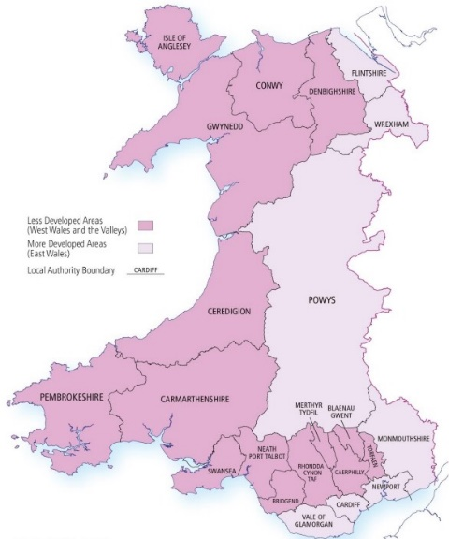The Technocamps programme includes the following sub-brands and projects:

* Technocamps ESF
  + WEFO funded
  + STEM enrichment in Secondary Schools
  + West Wales and Valleys convergence area
* Technocamps Secondary
  + Non-convergence area secondary schools
* Playground Computing
  + Welsh Gov funded
  + Primary schools
* Technoteach
  + CPD and upskilling of teachers
* Institute of Coding (IoC) and Swansea Degree Apprenticeships

For more information on the sub-branding see Section 6: Sub-brands on page 20 onwards.

# Colours

## Core Colours

### Usage

The core colours should be use appropriately for text logos and backgrounds. Main logos should always be comprised of a combination of these colours.

Dark Grey should be used where possible in place of Black and Legacy Black listed in the additional colours.

### Palette

|  |  |  |  |
| --- | --- | --- | --- |
| Yellow | #E7CB1B | rgb(231,203,27) | cmyk(0,12,88,9) |
| Dark Grey | #4A4947 | rgb(74,73,71) | cmyk(0,1,4,71) |
| Li­ght Grey | #95918F | rgb(149,145,143) | cmyk(0,3,4,42) |
| White | #FFFFFF | rgb(255,255,255) | cmyk(0,0,0,0) |

## Additional colours

### Usage

The Green, Raspberry and Blue colours should be used sparing and not on the main logo.

Acceptable uses are for projects such as Technoteach and Playground computing as well highlighting in documents and presentations

### Palette

|  |  |  |  |
| --- | --- | --- | --- |
| Black | #000000 | rgb(0,0,0) |  |
| Green | #8DB403 | rgb(141,180,3) | cmyk(22,0,98,29) |
| Raspberry | #9A0A63 | rgb(154,10,99) | cmyk(0,94,36,40) |
| Blue | #1FAFE6 | rgb(31,175,230) | cmyk(87,24,0,10) |
| Le­gacy Black | #3F3F3E | rgb(63,63,62) | cmyk(0,0,2,75) |

# Logos

## Which logo should I use?

Choice flow-chart

## Exclusion area

To achieve maximum legibility there is an exclusion zone around the logo as shown below. No other graphics should be present within this exclusion area.



## Sizing

In order to ensure readability of the blurb, the minimum printed height of the can be determined by the height of the “t” character being 5mm.



Logos should always be proportionally scaled and **never stretched or skewed**.

## Variants

### Main logo

#### Usage

This is the primary logo that should be used on any materials likely to be distributed to schools, teachers, pupils or parents.

#### Colour Variants

##### Light background - Yellow and grey



##### Dark background - Yellow and white



##### Yellow background - Grey and White



### Variants

#### High contrast all-black

#### Bordered

#### Square offset logo



##### Usage

This logo variant is to be used in square profile pictures such as on social media where the landscape logo variant would be too small to read such as on mobile screens.

For more information on social media, see Section 7: Social media on page 24.

##### Example

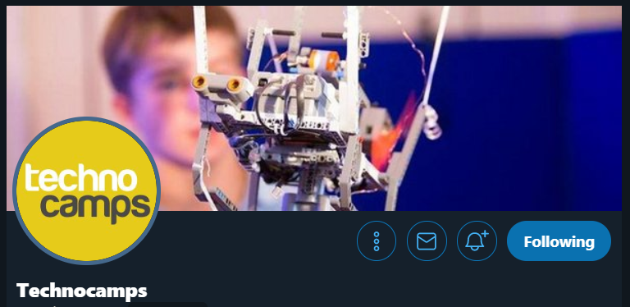

## Glyphs and icons

### Usage

Provided below are the new glyph icons that can be used on marketing materials and workbooks. The palette of glyphs and Raspberry and Green colour variants can be seen below

### Palette



### Colours

|  |  |  |
| --- | --- | --- |
|  |  |  |

### Elements

#### Googly



#### Claudia



#### TP

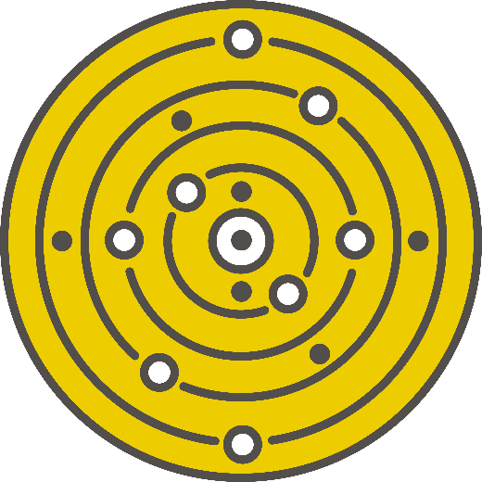

#### TriHard



#### Dalek



#### Brainy



#### Robbie



#### Ray



#### Simmy



#### Caterpillar

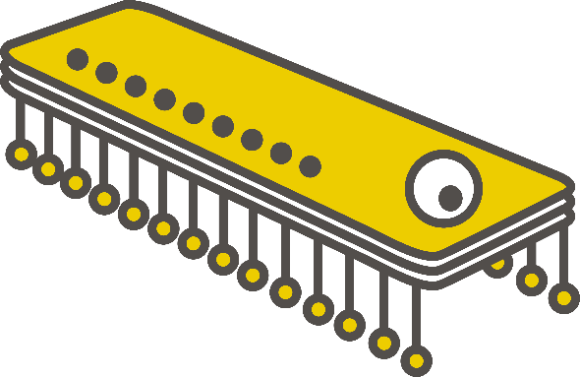

#### Handy Andy



#### Mind-Map

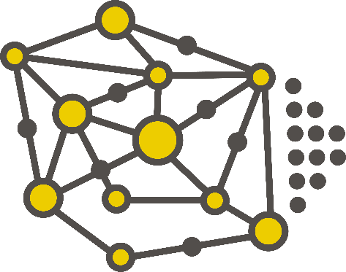

## Man and woman

### Usage

The old cartoon man and woman characters are to be phased out and replaced by the new versions shown below.

### Preview



# Fonts

## Harabara

### Usage

Harabara is the unmodified version of the font used in main body of the Technocamps logo. The main difference being the width of the ‘t’ character

### Sample

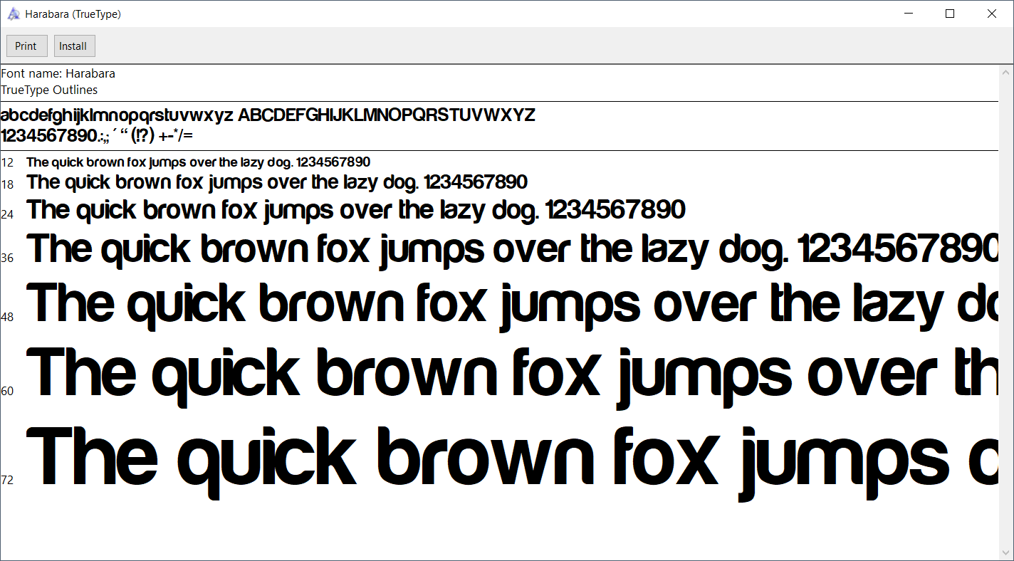

## Bariol Bold

### Usage

This font should be used for any surrounding text in logo variants. It is also appropriate to use this font for headings and titles in documents.

For systems where Bariol is not installed, **Arial Rounded** can be used as a good stand-in

### Sample

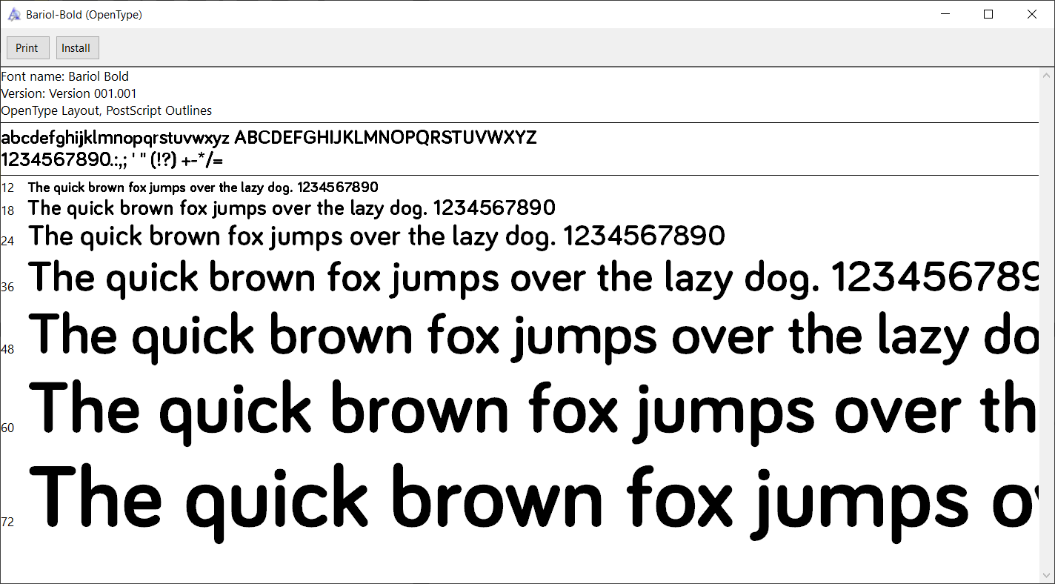

Arial rounded:

The quick brown fox jumps

# Email signatures

## Sample

Julie Walters

Uwch Reolwr Prosiect | Senior Project Manager

Technocamps

Tel/ffôn: 07987 654321 / 01792 513753

[technocamps.com](http://www.technocamps.com/)

@Technocamps

[](https://www.instagram.com/technocamps/) [](https://www.facebook.com/Technocamps-292590887455314/)





# Sub-brands

## STEM Enrichment

### Logos

#### Usage

The following should be used when branding Secondary STEM Enrichment materials.

#### For Light Backgrounds



#### For Dark Backgrounds



#### For Yellow Backgrounds



## Playground Computing

### Colour Palette

|  |  |  |  |
| --- | --- | --- | --- |
| Orange | #F7941D | rgb(247,148,29) | cmyk(0,40,88,3) |
| Aqua | #40ADBF | rgb(64,173,191) | cmyk(66,9,0,25) |

### Logos

#### Playground Computing with Technocamps

##### Usage

This should be considered the “primary” Playground Computing logo and should be used on materials where there is not already a prominent Technocamps logo.

##### For Light Backgrounds



##### For Dark Backgrounds



##### For Yellow Backgrounds



#### Playground Computing

##### Usage

The standalone Playground Computing logo should be used only when there is already clear Technocamps branding on the same page or document.

##### For Light Backgrounds



##### For Dark Backgrounds



##### For Yellow Backgrounds



## Technoclub

### Logos

#### Technoclub with Technocamps

##### Usage

This is the primary Technoclub logo that should be used on all Technoclub materials unless there is already a prominent Technocamps logo present on the same page/document.

##### For Light Backgrounds



##### For Dark Backgrounds



##### For Yellow Backgrounds



#### Technoclub Standalone

##### Usage

The following standalone Technoclub logo should only be used when there is a prominent Technocamps logo present on the same page/document or with the logo is being used small print.

##### For Light and Dark Backgrounds





##### For Yellow Backgrounds



## TechnoTeach

## GiST

### Logos

#### GiST with Technocamps

##### Usage

This is the primary GiST logo that should be used on the majority of materials unless there is limited print size or there is already a prominent Technocamps logo

##### For Light Backgrounds



##### For Dark Backgrounds



##### For Yellow Backgrounds

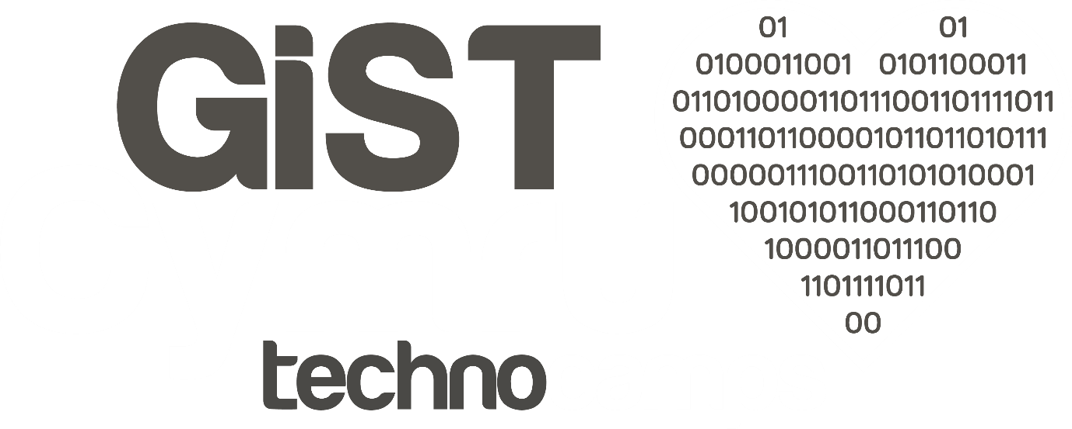

#### GiST with Heart

##### Usage

This logo is for medium to large print where there is already a Technocamps logo present on the page/document.

##### For Light Backgrounds



##### For Dark Backgrounds



##### For Yellow Backgrounds

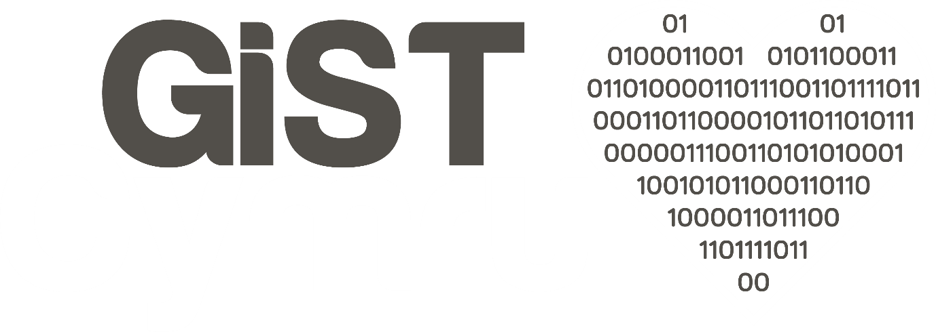

#### GiST Core Text

##### Usage

This logo should only be used in small print such as document headers/footers. Ideally this should be paired with the small Technocamps logo.

##### For Light Backgrounds



##### For Dark Backgrounds



##### For Yellow Backgrounds



# Partner and Funder logos

Wherever possible, the ESF and partner logos should be included on marketing materials.

Much like it is not always appropriate to use the full logo with blurb, there are also cases where the partner logos and ESF logo would either be unreadable or distracting.

Presentation of the ESF logo is of higher priority than the partner logos so all the partner logos should be dropped before the ESF logo when space or size is limited. Only if there is still not enough space should the ESF logo then be dropped.

## Logo strip

INSERT NEW LOGO STRIP HERE

Insert

### Just universities

### Universities with WG

### Universities with ESF

## Other logos

### ESF

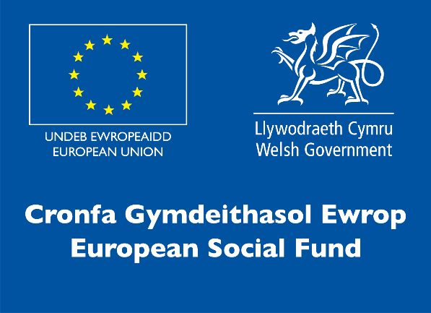

### Partners

#### Swansea University



#### Aberystwyth University



#### Bangor University



#### Cardiff Metropolitan University



#### Cardiff University



#### University of South Wales



#### Wrexham Glyndwr University



# Social media

## Twitter

### Mentioning and account tagging

Always endeavour to tag appropriate and related accounts for example the Universities or Lego Education etc.

In cases where space is limited, additional tags can be included in image posts, by tagging accounts in the actual image.

This tweet was successful because although it had limited hashtags, it was retweeted by @firstlegoleague that has 38.9K followers

<https://twitter.com/Technocamps/status/1121366139450294272>

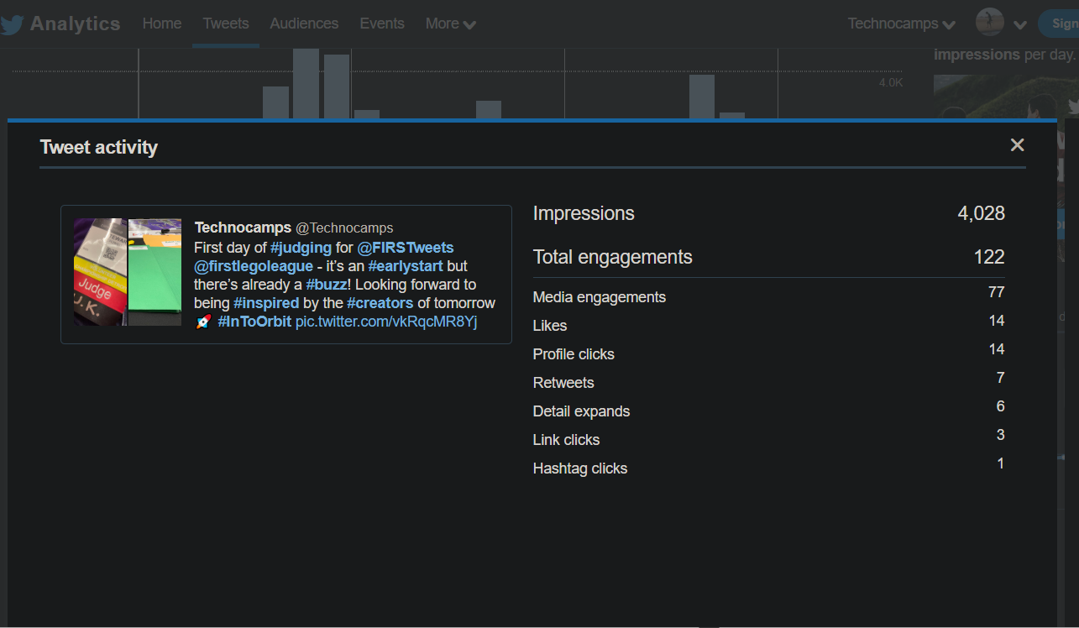

### Hashtags

Content discover is driven slightly less on Twitter than Instagram as it is not possible to follow hashtags on Twitter. As a result the window of visibility is smaller. Due to the more limited length of Tweets, it is also more important that you make sure you’re not using space on a low-popularity hashtag when it could be replaced by a more popular one.

This tweet, thought it had a few good retweets most of were from smaller accounts. Though there were far more likes. We cannot get detailed per-post breakdowns on hashtag, we can see the general popularity and correlation with other hashtags as seen here for the **#welsh** hashtag. As many of the likes were from accounts that do not follow us and we do not follow, we can assume they’ve engaged with this tweet because of the hashtags

<https://hashtagify.me/hashtag/welsh>

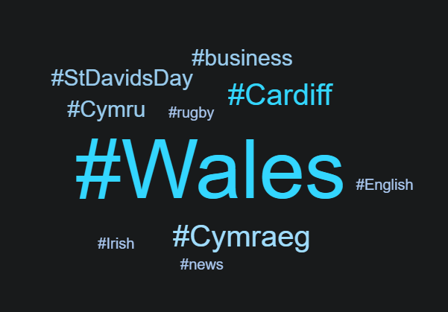

<https://twitter.com/technocamps/status/1121664995773702144>

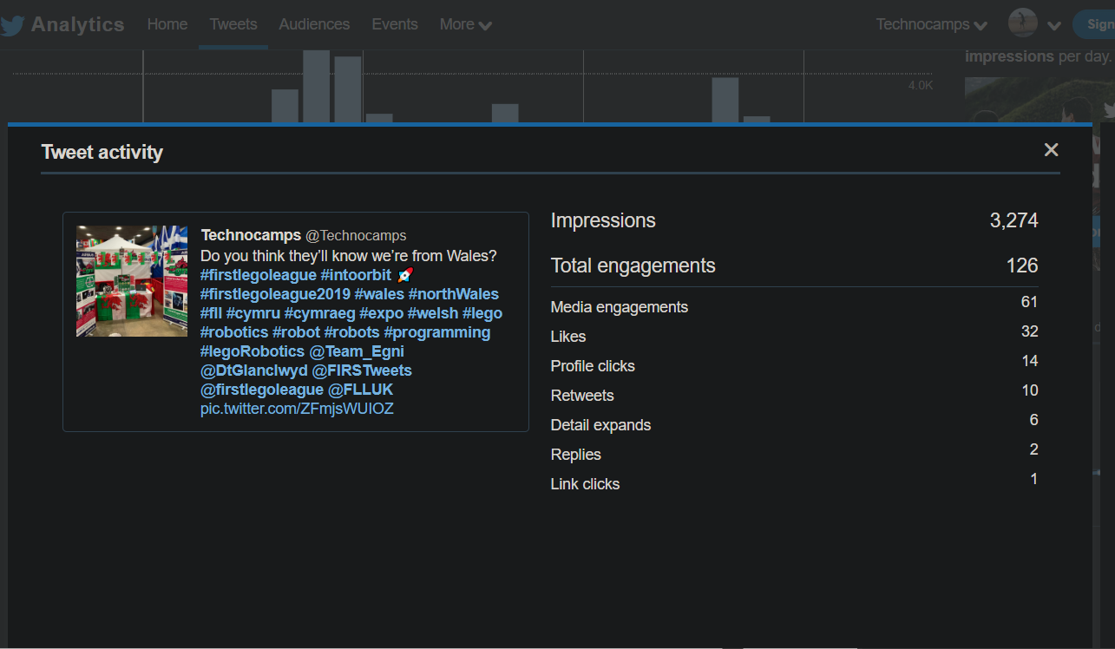

## Instagram

## Facebook

# 

Use of Logos

Technocamps Programme

As you will note from the structure of the programme, Technocamps is the overarching brand for:

* Technocamps ESF (Secondary Schools in Convergence Areas)
* Technocamps Secondary schools
* Playground Computing (Primary Schools)
* IOC and Degree Apprenticeships
* Technoteach

A degree of discretion and common sense will therefore need to be applied when deciding on which logos to use in which context.

As a rule of thumb, any marketing materials likely to be distributed to schools and teachers should always include the logo with the blurb positioned to the left as below.



Marketing materials promoting the overarching brand can use logos without the blurb but should include the URL if possible.



We have approved the use of the ‘split’ logo for social media profiles and for where space is limited (such as on mobile phone pop-stands and coasters) – please double check with the marketing team if you wish to use this logo.



Please ensure that logos are scaled rather than stretched on any official documentation to maintain the integrity of the lettering and style.

Backgrounds and colours

Please adhere to the following guidance:

White background – Yellow/Grey logo (use black or dark grey font for body text)

Yellow background – Grey/white logo (use dark grey font for body text)

Dark Grey background – Yellow/White logo (use white font for body text)

Colours

Technocamps main official colours are as follows:

Please ensure that backgrounds and fonts adhere to this colour scheme wherever possible.

All printed and official marketing materials should use these colours.

If you are ordering any stock merchandise, please choose colours as close to the official ones as possible – if in doubt, send artwork to the marketing team for approval prior to ordering.

Please **do not use** the Technocamps Raspberry and Green on anything other than the colour coded workbooks unless given prior approval.

Fonts

All marketing materials should use Harabara font for main headlines and Bariol bold for body text. These fonts are in Owncloud folder should you need to download them.

ESF and partners’ Logo

Wherever possible the ESF and partners’ logos should be included on marketing materials. We appreciate however that this is sometimes not appropriate, especially if the logos will end up too small or distract from other important pieces of information. The standard logo strip with the ESF logo on (available on Owncloud), has been approved for all official documents.

There is also standard document format available on Owncloud which includes the logo strip which can be used for documents such as meeting minutes, press releases and any formal communications with external partners.

If in doubt, please check with the marketing team prior to documents being printed or sent out.

Icons and Brand Assets

All new and approved icons are available to use on marketing material and any workbooks being developed or edited. (Raspberry and Green versions are in the owncloud folder for use on the relevant colour coded workbooks).



The existing man and woman icon are to be phased out to be replaced by the new icons below which are more consistent with the new branding.

